eBilling and Invoice System

OBJECTIVE 1
Project Scope 2
Customer, Products, Billing Generation 2
Report Generation System 2
Out of Scope 3
Goal 3
Solution Concept 3
User Profiles 5
Usage Summary 6
Requirements Summary 7
Business Requirements 7
User Requirements 7
Operational Requirements 8
System Requirements 9
Success Criteria 9
Sales Automation 9
Design Goals and Constraints 10
Performance 10
Availability 10
Reliability 10
Scalability 10
Security 10
Interoperability 10
Location 10
Setup/Installation 10
Features/Functionality 10
Software and Hardware Requirement 13
General Requirement for Server/Client: 13
Development Tools and Technologies 13
Development Tools and Technologies 14
Front End 14
Back End 14
Development Environment 15
Use Case Summary 16
Manage Orders 16
Description 16
Business Need 16
Priority 16
Manage Products 16
Description 16
Business Need 16
Priority 16
Manage Contacts 16
Description 16
Business Need 16
Priority 17
Analyze Customers 17
Description 17
Business Need 17
Priority 17
Forecast Sales 17
Description 17
Business Need 17
Priority 17
Establish Sales Goals 17
Description 17
Business Need 17
Priority 17
Usage Scenarios 18
Use Case ID: UC 4.7.1 Retrieve Customer Data 18
Intent 18
Scenario Narrative 18
Assumptions/Preconditions 18
Actors 18
Basic Course 18
Alternate Course 18
Uses/Extends 18
User Implementation Requests 18
Frequency 18
Authority 18
Associated Specifications 19
Issues 19
Decision Points 19
Future Requirements 19
Modification 19
Use Case Model: Retrieve Customer Data 20
Use Case ID: UC 04.7.2 Manage Products 21
Intent 21
Scenario Narrative 21
Assumptions/Preconditions 21
Actors 21
Basic Course: 21
Alternate Course: 21
Uses/Extends 21
User Implementation Requests 21
Frequency 21
Authority 21
Associated Specifications 21
Issues 22
Decision Points 22
Future Requirements 22
Modification 22
Use Case: Manage Products 23
Use Case ID: UC 04.7.3 Manage Orders 24
Intent 24
Scenario Narrative 24
Assumptions/Preconditions 24
Actors 24
Basic Course: 24
Uses/Extends 24
User Implementation Requests 24
Frequency 24
Authority 24
Associated Specifications 25
Issues 25
Decision Points 25
Future Requirements 25
Modification 25
Use Case ID: UC 04.7.3 Manage Contacts 27
Intent 27
Scenario Narrative 27
Assumptions/Preconditions 27
Actors 27
Basic Course: 27
Uses/Extends 27
User Implementation Requests 27
Frequency 27
Authority 27
Associated Specifications 27
Issues 28
Decision Points 28
Future Requirements 28
Modification 28
Solution Architecture 30
Infrastructure 30
Visual Design 30
Conceptual Design 30
Logical Design 32
Physical Design 34
eBilling and Invoice System Data Dictionary 35
eBilling and Invoice System Data Dictionary 36
Table : product_master 36
Table : bill 36
Table : bill_details 37
Table : Company_master 37
Table : user_master 38
eBilling and Invoice System – Data Schema ER Diagram 39
eBilling and Invoice System DFD (Data Flow Diagram) 40
Form Design and Coding 41
FrmSplash 41
FrmLogin 43
FrmMain 46
FrmProducts 48
FrmBill 54
FrmReports 71
FrmPrintBill 73
ProductSummary Report 75
FrmBillSummary 76
FrmExportData 78
FrmUtlity 84
FrmCompactAndRepairDatabase 86
FrmBackupDatabase 88
FrmCompanyInfo 91
FrmClientInfo 96
FrmChangePassword 101
ModGen 103
ModBrowse 105
ModRsToWord 107
eBilling and Invoice System Test Plan 111
Introduction 111
Test Scope 111
Test Strategy 111
Preconditions 112
Test Priorities 112
Test Techniques 112
Test Organization 113
Roles and Responsibilities 113
Deliverables 113
Test Environment 113
Hardware and Software 113
Testing Automation Software 114
Application Configuration 114
Test Management 114
Testing Schedules 114
Threats to Testing 115
Conclusion and future enhancement 116
Bibliography 117
Websites 117
Books 117

OBJECTIVE

This project is made for one of the big decorator services in Mumbai, they supply decorating item to film industry for movie shooting. Presently they issue their client handwritten invoice and they enter details in manual register. And maintain MS Excel file for product rate. They want computerization of their manual invoice and bill generation process.

The client uses MS Excel, and maintains their product list, customer list, and prints the invoice, however it is not possible them to share the data from multiple system in multi user environment, there is lot of duplicate work, and chance of mistake. When the product price are changed they need to update each and every excel file. There is no option to find and print previous saved invoice.

There is no security; any body can access any report and sensitive data, also no reports to find out the sales volume, stock list, and summary report. This eBilling and invoicing system is used to overcome the entire problem which they are facing currently, and making complete atomization of manual billing and invoicing system

High Level Solution Architecture

User Profiles
The following user types are expected for the eBilling and Invoicing System:

User | Brief Description of Use Actions
Sales Representative | Downloads and uploads customer and order information, which affects accounting, inventory and product data. View customer and product data as described in metrics, track orders and deliveries.
Manager | All sales representative use actions, and management reports, quota establishment, reporting and adjustment.
Accountant | View and print stocks, track orders. Update product details like price.
MIS Executive | Generate reports, view and print inventory reports, view and print stock reports.

Usage Summary
eBilling and Invoicing System Version 1.0 will address the following use cases. The complete usage scenarios will be completed during the information-gathering process. Use cases will be created and prioritized. Selected use cases will be expanded into usage scenarios and features that are derived from both use cases and the usage scenarios, as represented in the following diagram:

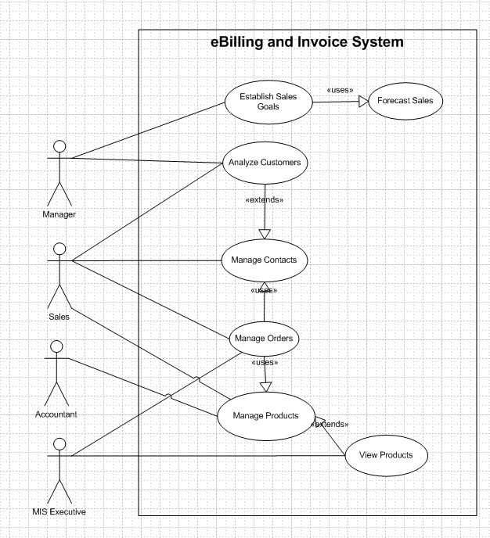

Usage summary use case

Requirements Summary
The following preliminary lists are based on initial interviews

Business Requirements
The business goal for the application is to support an increase the productivity and complete automation of existing manual bill and invoice generation process. Business requirements are discussed in the Scope section, with the following additional detail:

- Sales representatives need a method to store and access sales opportunity data, and when a sale is generated, convert some or all of the information into a sales order without re-entering information.
- Each sales representative should receive customer and sales data pertinent only to them.
- The accountant should be able to enter or update product information in one interface only, with all necessary product information being received by sales staff.
- Manager must receive his or her customer and appointment data plus detailed and rollup information for each sales representative on his or her team.
- The application should support the capability to use multi user environment.
- The MIS Executive should able to generate all type of reports as and when required by the management.

The sales staff wants to improve their current ability to analyze their customers. In particular, they want to focus on identifying their best customers and building long-term relationships within that base. To enable them to accomplish this goal, they want to extract meaningful data that easily answers the following questions:

- What are the early warning signs of problems?
- Who are my best customers across product lines?
- With whom do I focus my efforts for building a long-term relationship?
- What are my customers' issues as groups?
- Geographically, where are my best customers?
- What products are my customers buying and at what rate?

User Requirements
User requirements are categorized by user type.

Sales Staff (Representatives and Managers)

- View the data in various ways, for example:
  - Customers who are the top buyers of specific items
  - Best customers based on criteria to be determined
  - Best customers based on geographical analysis
  - Drops in a customer's sales
- Store multilingual and multiregional information in the database rather than relying on the sales staff to translate the information
- Identify which product prices have been modified, especially on current orders in progress
- Use opportunity rules, which are statements that help the sales representative convert an opportunity into a sale
- Add third-party data sources and financial evaluation tools
- Identify where promotions and programs would be the most beneficial
- Apply discounts to customer orders:
  - Sales representatives can offer discounts up to 15 percent, or up to 20 percent with authorization.
  - Sales managers can offer discounts up to 20 percent
- Enable capture, analysis, and sharing of data about a customer across the company
- Use forecasts to establish sales goals
- Allow all staff to view all contacts, but allow each contact to be assigned to a sales representative

Accountant

- Update product details, including price, photo, and description
- Add, delete, and update product specifications
- Generate stock reports and check the availability, order the item as and when needed.

MIS Executive

- Generate Reports as per requirement.
- Share the data, and convert reports to different format like Text, CSV.

Operational Requirements
The following requirements provide a high-level view of how the system will run:

- Processor usage should not exceed 80 percent during concurrent uses.
- Backups will occur incrementally throughout the day.
- A full weekly backup is required to WORM drives.
- Ensure that information is easy to access either, and meaningful for the sales representative and the company.
- Minimize the technical knowledge that sales and marketing staff need to access the data, generate ad hoc queries, track promotions, and view customer segmentation information.
- Any change to information must be reflected immediately, and the changes must be propagated to the search engine so that employees that perform searches see this new information.
- The application should work with the existing communications and networking infrastructure.
- The application should deploy with a minimum of additional operational processes, manual or otherwise.

System Requirements
These are additional constraints from a system perspective:

- Previous data of customer, product details must be imported in the new system.
- The administrator must be able to monitor everything from the IT department.
- The information must be accessible by everyone in the company as per the rights specify.

Success Criteria
To determine the success of this project, the following metrics can be quantified and used to analyze success factors.

Sales Automation
- Problem customer identification. Ability to identify top 10 developing problem customers by sales representative.
- Identification of best customers across product lines and regions. All customers can be sorted by the factors (to be determined) that rank them qualitatively. Variable sorts and rankings can be chosen by the sales representative.
- Identification of issues across groups. All customers can be sorted by the issues (to be determined) within group categories that can be updated. Variable sorts and rankings can be chosen by the sales representative or other user.
- Analysis of quantities and rates of products. Products can be sorted by the quantity and dates sold. Variable sorts and rankings can be chosen by the user.

Design Goals and Constraints

Performance
No more than a 5-percent degradation in average query response is allowed while all concurrent user are using the system.
Processor utilization should not exceed 80 percent during all concurrent users are using the system.

Availability
Because the system is accessed by sales representative to book the order and print the invoice, and their should not be any single point of failure.

Reliability
Because of the need no single point failure, automatic failover will be required. In addition, existing disaster recovery and backup plans and procedures must be revised to incorporate the eBilling and Invoicing System.

Scalability
eBilling and Invoice System an average load of 50 concurrent users after the system is fully operational, and expects that to grow by 5 percent each year for the next five years.

Security
For the sensitive customer and order data, all users will need to log on the system with their user id and password.

Every resource in the system are defined by the role and privileged. System administrator assigned user role and privileged for their access rights.

Interoperability
In Version 1.0 of the eBilling and Invoice System, there are no requirements for interoperability with other systems.

Location
The eBilling and Invoice System are used in the company office only.

Setup/Installation
Setup and installation must not interrupt the sales staff’s daily tasks and work flow.

Use Case Summary

Manage Orders

Description
This function will enable sales representative to place orders for eBilling and Invoice System products, track submitted orders, and view completed orders and print the invoice.

Business Need
This function will enable sales representative to interact with eBilling and Invoice System catalog directly without the intervention of any other employees.

Priority
High

Manage Products

Description
This function allows user of eBilling and Invoice System to create, maintain, and delete information about products in the product database that can then be viewed and ordered by customers, and accessed and updated by the sales staff.

Business Need
This function will support the sales staff with accurate and relevant information, and will also support the Manage Orders function by ensuring up-to-date product information.

Priority
High

Manage Contacts

Description
This function enables the sales staff to create and manage contacts as well as share contact information with the rest of the company.

Business Need
This function enables user of eBilling and Invoice System to have accurate and up-to-date contact information when working with customers.
Add new product to product master sequence diagram

